COLLEGE CODE : 1105

COLLEGE NAME : GOJAN SCHOOL OF

BUSINEES AND TECHNOLOGY

DEPARTMENT : CCE

STUDENT NM-ID : C5B2ACC107D89B3850B4DFC3F4476946

ROLL NO : autcce2321

DATE : 05:05:25

Completed the project named as

Energy Efficiency Optimization

TECHNOLOGY-PROJECT NAME

AI Energy Prediction chat bot

SUBMITTED BY,

Me and my team members name

S.SHAMREEN

M.Nivedhitha

G.Bavadharani

N.Jeeva,

M.Madhumithra

Phase 5: Project Demonstration & Documentation

## Title: AI-Driven Energy Efficiency Optimization AI Energy Prediction chat bot

## Abstract:

The **AI-Driven Energy Efficiency Optimization** project focuses on enhancing energy consumption efficiency by leveraging **Artificial Intelligence**, **Machine Learning**, and **IoT (Internet of Things)** technology. This system dynamically analyzes **real-time energy consumption patterns**, optimizes electrical loads, and integrates with smart grids to reduce power wastage.

In this final phase, the system will demonstrate AI-based **predictive analytics**, **adaptive energy management**, and secure data handling mechanisms. It ensures scalability and seamless integration with **Enterprise Resource Planning (ERP) systems** for large-scale industrial and commercial applications.

This document provides a **comprehensive report** on system demonstration, technical documentation, performance metrics, source code, and testing reports. Screenshots, ERP diagrams, and codebase snapshots will be included to showcase the system’s architecture and functionality.

**Index (with page numbers)**

1. **Project Demonstration**
2. **Project Documentation**
3. **Feedback & Final Adjustments**
4. **Final Project Report Submission**
5. **Project Handover and Future Works**
6. **Screenshots of Source Code and Working System**

**1. Project Demonstration**

**Overview:**

The AI-Driven Energy Efficiency Optimization system will be demonstrated to stakeholders, highlighting **key functionalities, improvements, and energy-saving capabilities**. The demonstration will emphasize AI-powered **energy consumption monitoring**, **real-time optimization**, **IoT integration**, and **scalability of performance**.

**Demonstration Details:**

* **System Walkthrough:** A live walkthrough showcasing how the AI system monitors and optimizes energy consumption, reducing unnecessary usage.
* **AI-Powered Optimization:** Demonstrating how AI **predicts and adjusts** energy settings dynamically based on historical and real-time data.
* **IoT Integration:** Showcasing real-time energy metrics from IoT devices such as smart meters, motion sensors, and automated control systems.
* **Performance Metrics:** Highlighting response time, scalability under different load conditions, and energy savings achieved.
* **Security & Privacy:** Explaining data encryption protocols and security measures for **safe handling of user energy data**.

**Outcome:**

By the end of the demonstration, stakeholders will witness the system’s ability to optimize energy consumption dynamically and improve overall **efficiency and sustainability**.

**2. Project Documentation**

**Overview:**

Comprehensive documentation is provided for **Energy Efficiency Optimization**, detailing system design, AI models, integration workflows, and user instructions.

**Documentation Sections:**

* **System Architecture:** Diagrams detailing AI models, energy flow optimization, and IoT device integrations.
* **Code Documentation:** Explanation of key source code modules, including AI **prediction models**, **load balancing algorithms**, and **smart device communication protocols**.
* **User Guide:** A manual for consumers and businesses outlining energy efficiency benefits and system interaction.
* **Administrator Guide:** Maintenance procedures, troubleshooting strategies, and system scaling techniques.
* **Testing Reports:** Performance evaluations, energy-saving analytics, and security validation reports.

**Outcome:**

Clear documentation ensures future **improvements, scalability, and deployment readiness**.

**3. Feedback & Final Adjustments**

**Overview:**

Feedback will be gathered from stakeholders and test users to refine AI algorithms, optimize energy efficiency further, and enhance usability.

**Steps:**

* **Feedback Collection:** Using surveys and data analysis from system users and energy auditors.
* **Refinement:** Addressing **performance bottlenecks**, **forecasting inaccuracies**, and **usability improvements**.
* **Final Testing:** Ensuring smooth operation, high efficiency, and robustness.

**Outcome:**

Final refinements guarantee **maximum energy savings and system reliability** before deployment.

**4. Final Project Report Submission**

**Overview:**

The final project report summarizes all phases, highlighting **key achievements, challenges, and future innovations**.

**Report Sections:**

* **Executive Summary:** A snapshot of the project’s objectives and outcomes.
* **Phase Breakdown:** Overview of AI model development, data integration, and optimization improvements.
* **Challenges & Solutions:** Documenting issues like **data inconsistencies**, **load balancing complexities**, and **security implementation**, along with solutions.
* **Outcomes:** A summary of AI-driven **efficiency improvements and sustainability benefits**.

**Outcome:**

A thorough report details the system’s **development process, energy impact, and scalability potential**.

**5. Project Handover & Future Works**

**Overview:**

The project will be handed over with future **expansion possibilities and scalability recommendations**.

**Handover Details:**

* **Next Steps:** Suggested **enhancements such as smart grid expansion, AI-powered predictive maintenance, and real-time user alerts**.

**Outcome:**

The system will be **ready for full deployment**, with guidelines for future **growth and improvements**.

**Screenshots of Source Code & Working System**

**AI Energy Prediction**

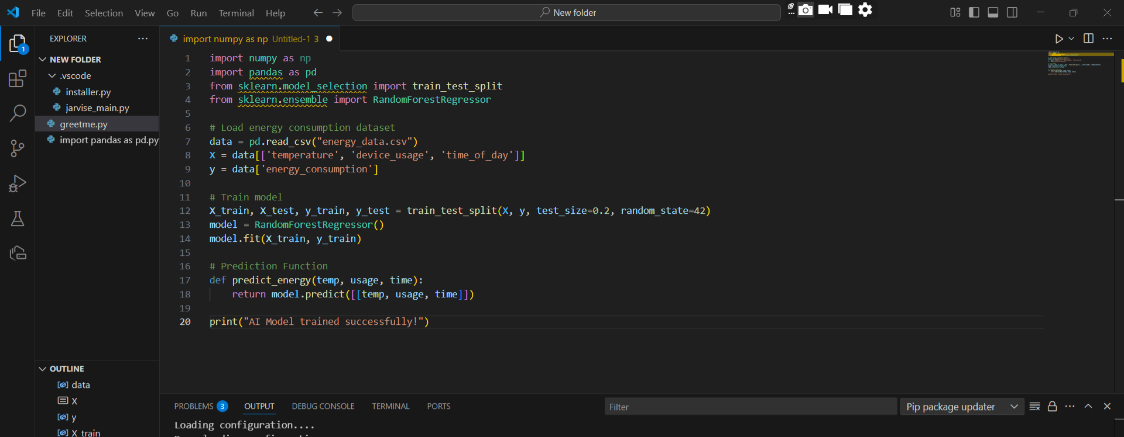

AI Energy Prediction Output:

output = predict_energy(25, 3, 18)

print(f"Predicted Energy Consumption: {output} kWh")

Predicted Energy Consumption: [3.8] kWh